Q2_ZHANG, XIAO_17204147

ZHANG, XIAO (17204147)

2020/6/9

library(ggplot2)

##Load packages

data <- read.csv("data.csv")

## Input the dataset from the local disk. The dataset contains the number of the recovered and death cases in Malaysia from 01/22/2020~06/07/2020.

head(data)

## Date Recovered Deaths  
## 1 1/22/20 0 0  
## 2 1/23/20 0 0  
## 3 1/24/20 0 0  
## 4 1/25/20 0 0  
## 5 1/26/20 0 0  
## 6 1/27/20 0 0

## It shows the first 6 rows in the dataset. We can see that the first column implies the date when data collected, second is the Recovered cases and third is Deaths.

tail(data)

## Date Recovered Deaths  
## 133 2006/2/20 6470 115  
## 134 2006/3/20 6531 115  
## 135 2006/4/20 6559 115  
## 136 2006/5/20 6610 116  
## 137 2006/6/20 6635 117  
## 138 2006/7/20 6674 117

## This are the last 6 rows.

dim(data)

## [1] 138 3

## Now we know the dataset totally has 420 rows and 4 columns.

input <- data[,c('Recovered', 'Deaths')]  
ggplot(input, aes(x=Recovered, y=Deaths, col="#C80815" ))+geom_point()

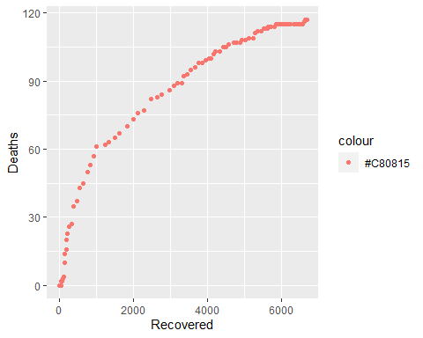

## Plot a scatter plot shows the relationship between total number of the recovered and death cases.From the plot we can know that there is a strong linear relationship between those two variables.

hist(data$Recovered,col="steelblue",xlab="Recovered Cases", main='Histogram plot for Recovered Cases ')

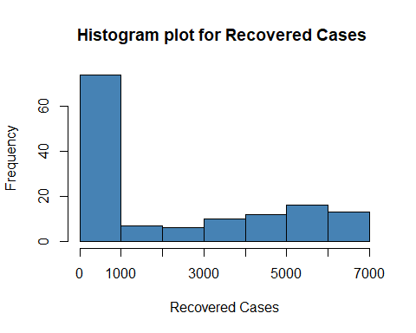

## Plot the histogram for “Recovered Cases”

hist(data$Deaths,col="steelblue", xlab="Deaths", main='Histogram plot for Dead Cases')

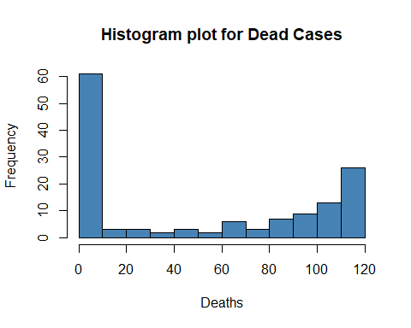

## Plot the histogram for “Death Cases”

df <- data[which(rowSums(data==0)==0),]

## Clean the zero numbers, since too many empty values may distruct the plot.

boxplot(Recovered~Deaths, data=df, xlab='Deaths', ylab = 'Recovered Cases', main='Boxplot for Recovered~Dead Cases', col="red")

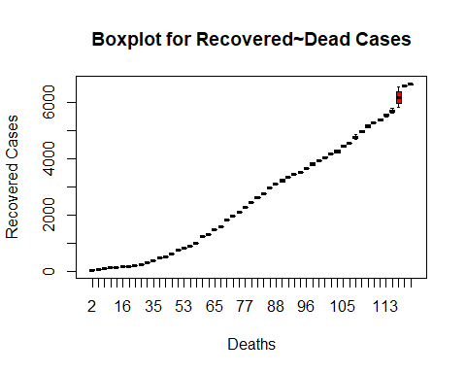

## Plot a boxplot to show the realationship between Recovered and Death numbers. It indicates that those two variables has a correlated upheaval relationship. The force to rise up and get down between those two are Complementary.